**Ex. No. : 5**

**SELECT with various clause – BETWEEN, IN, Aggregate function**

**Questions:**

**QUESTIONS:**

1. List the type of the courses “DBMS” and “ds”

Ans)

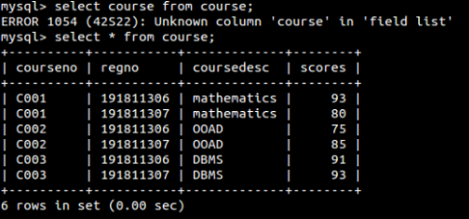

1. The instructor wants to know the CourseNos whose scores are in the range 50

to 80

Ans)

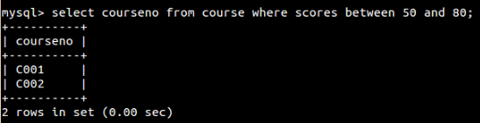

3.List the no of faculties in each department

Ans)

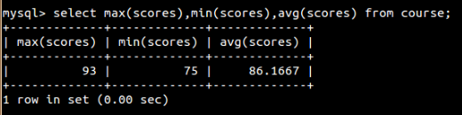

4.List the name of the courses and average mark of each courses.

Ans)

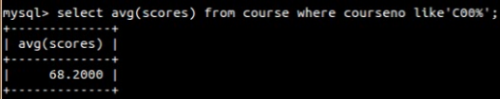

5.Calculate the sum of all the scores.

Ans)

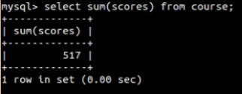

6.How many students are registered for each course

Ans)

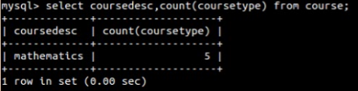

7.Display the sum of salaries in each department.

Ans)

